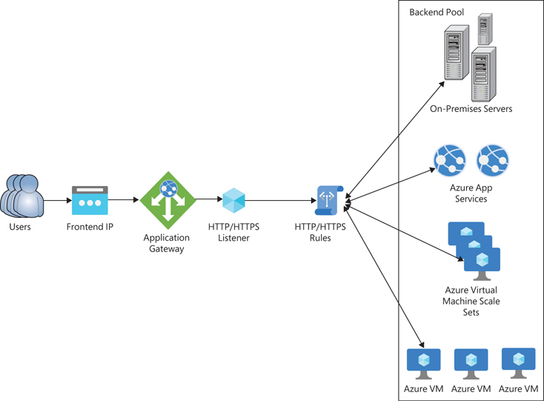

Application Gateway:

👉 Azure Application Gateway is a Layer 7 (HTTP/HTTPS) Load Balancer
It can:
- Route traffic based on URL / path
- Provide WAF (Web Application Firewall)
- Terminate SSL
- Act as Ingress Controller for AKS

🧩 Components of Application Gateway

🔹 1. Frontend IP
👉 Entry point for users
- Public IP (internet users)
- Private IP (internal apps)

🔹 2. Listener
👉 Listens for incoming requests
- HTTP / HTTPS
- Port (80 / 443)
- Domain-based routing

🔹 3. Backend Pool
👉 Where traffic is sent
- VMs
- App Services
- AKS services

🔹 4. Backend Settings
👉 Defines:
- Port (e.g., 80, 8080)
- Protocol (HTTP/HTTPS)
- Health probe

🔹 5. Routing Rules
👉 Connects:
- Listener → Backend
Types:
- Basic
- Path-based

🔹 6. WAF (🔥 Important)
👉 Protects from:
- SQL injection
- XSS attacks

🔹 7. Health Probes
👉 Checks backend health
- If unhealthy → traffic not sent

🛒 E-Commerce Scenario (INTERVIEW GOLD)

